2019-2020 ACADEMIC YEAR ...................... HIGH SCHOOL
1ST TERM 1ST WRITTEN ENGLISH EXAM FOR THE 10TH GRADES

Name Surname : __________________________ Date : ... . .2019
Class – Number : __________________________ Point : ________
- READ THE PASSAGE AND ANSWER THE QUESTIONS. WRITE TRUE or FALSE. (5*5=25 POINTS)
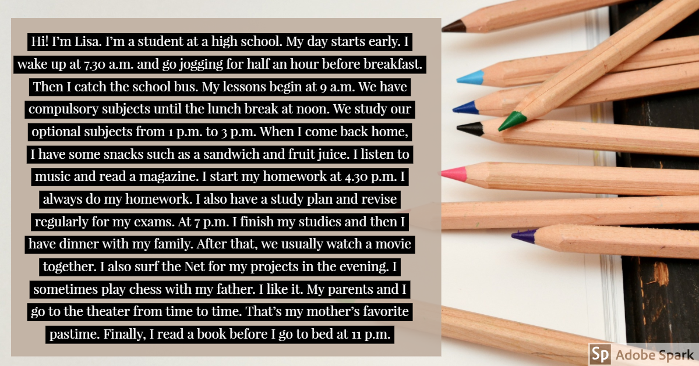
- Before breakfast, Lisa goes jogging for about thirty minutes. .............................................
- In the afternoon, they have optional subjects for three hours. ............................................
- She doesn’t eat anything until dinner. ........................................
- Lisa and her father sometimes play chess together . ........................................
- Lisa’s favorite pastime is going to the theater. ..............................

- MATCH THE IDIOMS/PROVERBS WITH THEIR MEANINGS. (5*4=20 POINTS)

- Every difficult or unpleasant situation has some advantages.
............................................................................................................................................................................................................
- What can you say instead of ‘ I don’t like it’ ?
.............................................................................................................................................................................................................
- It’s a good idea to do something immediately instead of delaying.

…………………………………………………………………………………………………………………………………………………….

- What do call a person who works hard to be successful?

………………………………………………………………………………………………………………………………………………………

- If you say you feel over the moon, how do you feel?

……………………………………………………………………………………………………………………………………………………….

The early bird gets the worm | Knowledge is power | Every cloud has a silver lining | Hit the books
Very happy | It isn’t my cup of tea | There’s no time like the present. | Eager beaver

- MATCH THE SENTENCES WITH THE PLACES. (6*3=18 POINTS)
- Class 9B are in the ............................... now as they have PE lessons.
- Class 9E are in the ............................................... They’re doing an experiment at the moment.
- Class 10A have art lessons so they’re in the ................................................
- Class 10C are in the ............................................................. They’re practising for the school concert.
- Class 11D are in the ............................................................. They’re learning to develop a web page.
- Class 11F are in the ...................................................................... They’re doing research on famous Turkish poets.
Computer lab | Staff room | Library | Science lab
Canteen | Gym | Music room | Art room

- ANSWER THE QUESTION BELOW. USE THE FUTURE TENSE FOR PLANS (BE GOING TO). (18 POINTS)

- WRITE A SUITABLE ANSWER FOR EACH SITUATION. USE THE FUTURE TENSE FOR SPONTANEOUS DECISIONS AND PREDICTIONS.(WILL) (19 POINTS)
- You’ve just arrived home, but you realize you’ve forgotten to buy milk.

......................................................................................................................................................................

- Your elder sister needs help with the housework.

.......................................................................................................................................................................

- Your cousin is at your house. He says ‘It’s very cold in here!’.

......................................................................................................................................................................

- You’re leaving home for school. Your mum says ‘I think it will rain.’

......................................................................................................................................................................

