Name &Surname:
Class &Number:

2019-2020 ACADEMIC YEAR TEVFİK KUT SECONDARY SCHOOL 5TH GRADES 1ST SEMESTER
1ND WRITTEN ENGLISH EXAM

1.What time is it ?
A.it is half past seven 08:00
B.It is three o’clock
C.It is five o’clock
D.It is eight o’clock

2.What time is it?
A.It is half past eight
B.It is half past six
C.It is half past four
D.It is half past nine

3.What does he do?
A.Do homework
B.Have breakfast
C.Go to school
D.Play volleyball
4.Where are they?
A.Bakery
B.Police station
C.Hospital
D.Post office

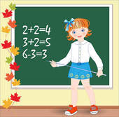
5.Which lesson is it?
A.Turkish
B.Maths
C.P.E.
D.Art

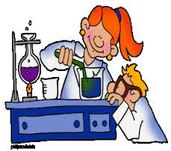
6.Which lesson is it?
A.English
B.Science
C.Art
D.Turkish

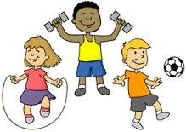
7.Which lesson is it?
A.Physical Education
B.Turkish
C.Maths
D.Science

(SORULARA EN UYGUN CEVAPLARI BULUN)
8.Where are you from?
A.I am 12 years old
B. My name is Selin
C.I am from Turkey
D.My favourite lesson is Science

9.How old are you?
A.I am 15 years old
B.I like chess
C.My name is Canan
D.I am from İzmir

10.What are you favourite lessons?
A.My favourite lessons are Turkish and Maths
B.I am from France
C.I am 10 years old
D. I don’t like chess
11.What does he like?
A.Blind man’s buff
B.Hide and seek
C.Origami
D.Chess
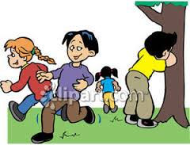
12.What do they like?
A.Chess
B.Hide and seek
C.Volleybal
D.Origami

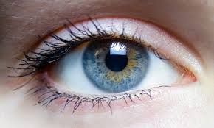
13.Which body part is it?
A.Hand
B.Leg
C.Eye
D.Hair

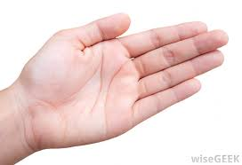
14.Which body part is it?
A.Hand
B.Mouth
C.Shoulder
D.Knee
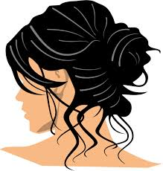
15.Which body part is it?
A.Hair
B.Foot
C.Finger
D.Stomach

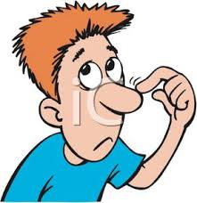
16.Which body part is it?
A.Leg
B.Stomach
C.Knee
D.Nose

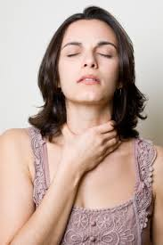

17.What is the matter with her?
A.Earache
B.Backache
C.Sore throat
D.Runny nose

18.What is the matter with her?
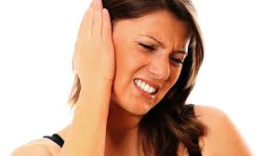
A.Flu
B.Backache
C.Earache
D.Fever

19.What is the matter with her?
A.Toothache
B.Flu
C.Cough
D.Headache

20.What is the matter with him?
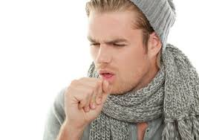
A.Stomachache
B.Backache
C.Cough
D.Headache

 | A | B | C | D
1
2
3
4
5
6
7
8
9
10
11
12
13
14
15
16
17
18
19
20

https://www.sorubak.com

1

