2019-2020 ACADEMIC YEAR KİLEDERE RELIGIOUS VOCATIONAL SECONDARY SCHOOL
THE 6TH GRADE THE 1ST TERM THE 1ST WRITTEN EXAM:
NAME: SURNAME: NUMBER: CLASS:
A.Resimlerle aktivite isimlerini eşleştiriniz. ( 8*3=24 PTS ) https://www.sorubak.com
3A
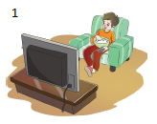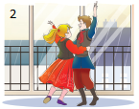
7
A. Run errands____ B. Take care of pet____ C. Watch TV ____ D. Wake up ____
E. Do homework ____ F. Play soccer ____ G. Take folk dance course ____ H. Take a nap____

B)MATCH THE CLOCKS WITH THE SENTENCES:(Cümlelerle saatleri eşleştir) (8x2=16pts)
    - It is quarter to ten 5. It is ten to one
    - It is half past eleven 6. It is twenty to nine
    - It is quarter past seven 7. It is twenty past one
    - It is 5 o’clock 8. It is ten past ten
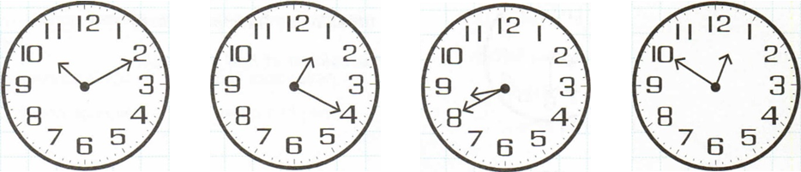

…………………………… …………………………… …………………………… ……………………………
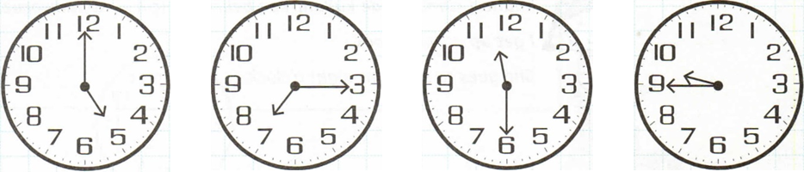
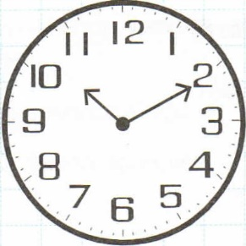
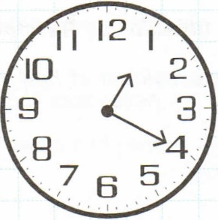
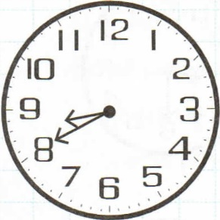
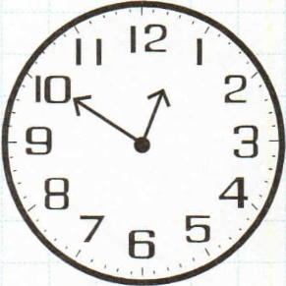

…………………………… …………………………… …………………………… …………………………… C) Match the questions with the correct answer(SORU VE CEVAPLARI EŞLEŞTIRINIZ).(5.3=15 pts)
1.What do you do after school on Mondays?__ A) cheese, olive, sausage, and omelette
2.What time do you have breakfast?___ B) at 7 o’clock
3.What do you eat at the breakfast?___ C) I have a rest and do my homework
4.What do you eat at the breakfast?___ D) milk or tea
5.Do you like honey and butter? ___ E) Yes, I do
D) READ THE TEXT AND WRITE “TRUE or FALSE”(5.3=15 PTS)
My name is Çağlar.I have a small family.My little brother is seven years old. He’s a primary school student. I go to secondary school. I get up at eight o’clock every day because my classes start at nine. I have a big breakfast with my family. I play soccer with my classmates on Thursdays. I go to folk dance courses every Monday .I go to bed at 10.30 every night.
- Çağlar has a one sister._______
- Çağlar gets up at 8 o’clock every day._______
- The classes starts at ten o’clock.__________
- Çağlar plays footbal with his classmates on Wednesdays .________
- Çağlar go to ped half past ten every night.__________

E)Match the pictures with the suitable words. (Kelimelerlerle esimleri eşleştiriniz.Resimlerin altına sadece sayıları yazınız. )(12*2 = 24p)
1.croissant 5.orange juice 9.honey
2.bread 6.jam 10.french fries
3.salami 7.cucumber 11.olives
4.muffin 8.tea 12.butter

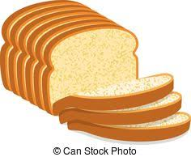
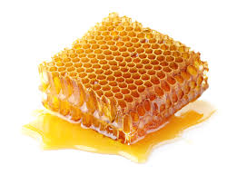
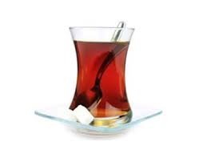

………………… ………………… ………………… ………………… ………………… …………………
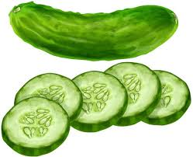
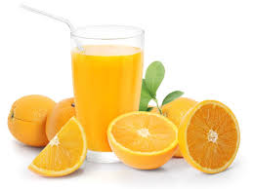
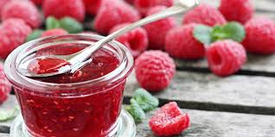

………………… ………………… ………………… ………………… ………………… ………………
F) Complete the table.(Tabloyu METİNDEKİ BİLGİLERE GÖRE TAMAMLAYINIZ)8 pts

Hi my name is Sema. I study in Kiledere secondary school. I’’m at 5th grade. I have breakfast with my family every day before I go to school. I like eating salami and sausages at breakfast but ı don’t like croissant . My mother love cheese and olive but she hates butter and croissant. Omelette is my father’s favourite food. But he doesn’t like toast.
 | SEMA | HER MOTHER | HER FATHER

GD LUCK ELT- CANAN ÜZER

