…………………ORTAOKULU 7.SINIF İNGİLİZCE 1. DÖNEM 1. YAZILI SORULARI
Çoktan Seçmeli Soruları yap. 5*5=25 p
1. Aşağıdakilerden hangisi kişilik veya dış görünüş olarak farklıdır?
A) Plump B) Well-Built
C) Hazel Eyes D) Outgoing
2. Soru
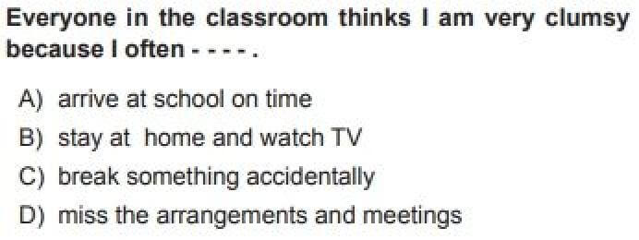
3. Rebecca is a/an ________ person. She is Hardworking and Study.
A)Stubborn B)Clever
C)Forgetful D)Clumsy
4. Sue: What does Selena Gomez look like?
Pete:________________
Hangisi olamaz?
A) She is tall. C) She is honest.
B) She is slim. D) Has big Brown eyes.
5. She is very ___________. Because never changes here mind.
A) Cute B)Quiet C) Generous D) Stubborn
6.Kelimelerin anlamlarını yazın. 10*2=20p
Train: Match :
Sports: Equipment:
Gym: Slim: Stubborn:
Plump : Smart: Outgoing:
AD-SOYAD:
SINIF-NO:
7. Hangileri Kişisel özelliktir? Yuvarlak içine alınız.
12*1=12p
Stubborn Shy Cute Help
Attractive Ugly Beautiful Clever
Handsome Hardworking Clumsy Outgoing
8. Aşağıdaki kelimelerden doğu olanları yuvarlak içine alın 10*2 =20
We have/has a nice garden.
I usually get /gets up at 6 o’clock.
My father always watch /watches the news on TV in the evenings.
Jane study/ studies lesson hard.
She want/wants to be a doctor.
Mr and Mrs Smith live/lives in New York.
My sister tidy / tidies her room every morning.
I always have/ has breakfast in the morning.
People usually take/takes an umbrella in Britain.
Monkeys eat /eats bananas a lot.
9. Aşağıdaki karşılaştırmaları yapın. 7*2=14p
Konya is ________________(large) İstanbul.
Antalya is ___________________(crowded) Burdur.
Sude is ___________________(beautiful) Sıla.
Kemal is _______________(clever) Hande.
Salim is _________________(tall) Rana.
SIA is _________________(Good) BTS.
Merve is ________________(short) Aslı

10. Kendi Gününüzü Anlatan bir Kompozisyon yazınız. 8p

https://www.sorubak.com

BASARILAR …
INGILIZCE OGRETMENI
…………………………………………………

https://www.sorubak.com

