2019-2020 ACADEMIC YEAR ...................... HIGH SCHOOL
1ST TERM 1ST WRITTEN ENGLISH EXAM FOR THE 9TH GRADES

Name Surname : __________________________ Date : ... . .2019
Class – Number : __________________________ Point : ________

- READ THE DIALOGUE AND ANSWER THE QUESTIONS. WRITE TRUE or FALSE. (5*5=25 POINTS)
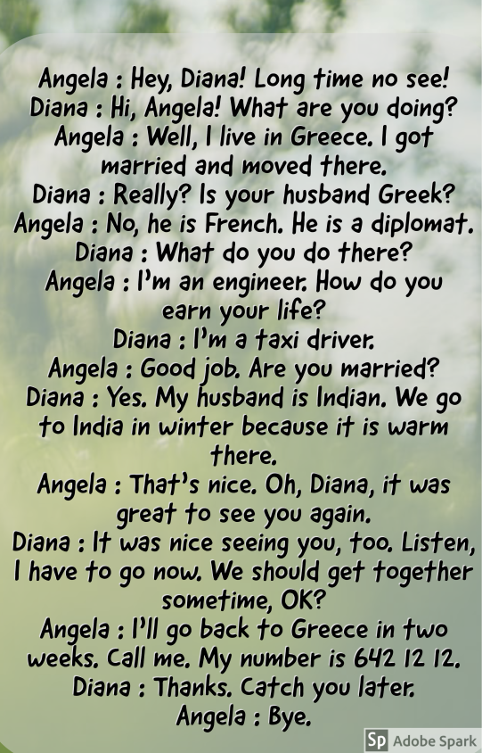
- Angela and Diana often come together. ...............................
- Angela’s husband is a diplomat in France. .........................
- Diana’s husband is a taxi driver. .......................
- Angela invites Diana to Greece for two weeks. .........................
- They agree to meet sometime. ........................

- ANSWER THE QUESTIONS CAREFULLY. (4*4=16 POINTS)
- How many boys are there in your class? ........................................................................................................................................................
- Is there a bookshelf next to the smart board in your class? ...................................................................................................................
- Who has got glasses in your class? ....................................................................................................................................................................
- How many cities are there in Turkey? ...............................................................................................................................................................

- READ AND MATCH THE JOBS. ( 2 jobs are extra!) (3*5=15 POINTS)
An architect | A builder | An accountant | A surgeon | A lawyer | A plumber | A teacher
- .......................................................................works at the hospital, operates on people.
- ......................................................................works at a courthouse.
- .......................................................................helps build a house or a building.
- ........................................................................designs houses and buildings.
- .......................................................................keeps financial records.

- COMPLETE THE DIALOGUE WITH THE PHRASES BELOW. CHOOSE ONE FROM THE BOX. (9*2=18 POINTS)
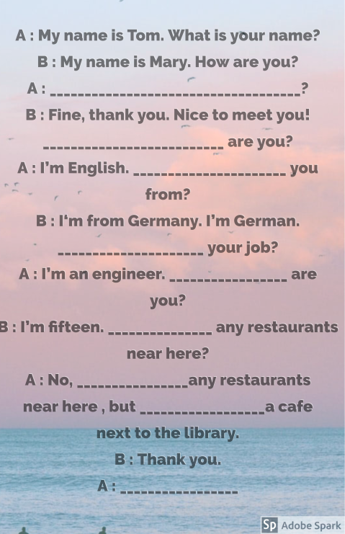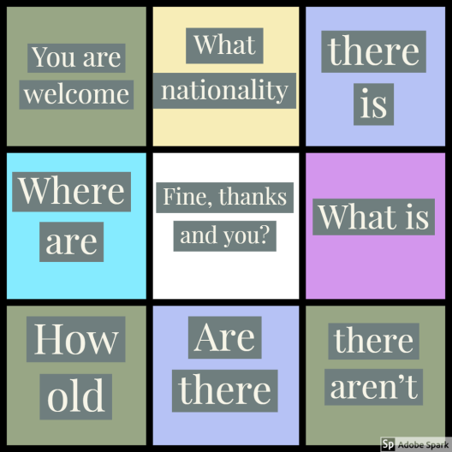
- FIND THE PLACES ON THE MAP ACCORDING TO THE DIRECTIONS BELOW. (3*4=12 POINTS)
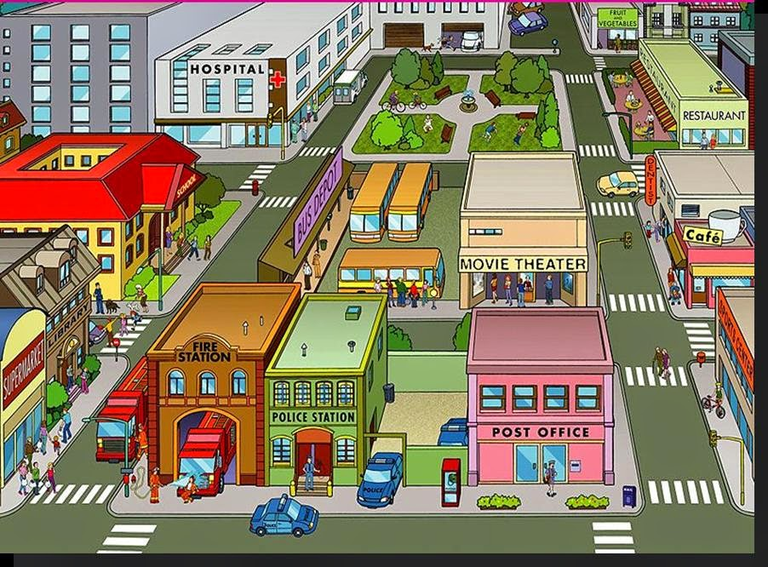
- Start from the Police Station. Go past the Post Office. Cross the street. You are now in front of the Sport Center. Take the second turning on the right. .............................................. is opposite the Dentist.
- Start from the Supermarket. Go past the library. Cross the street carefully. .......................................is on the left.
- Start from the Hospital. Cross the street and go across the Park. Go down the street. Go past the movie theatre. .................................... is next to the Cafe.

- ANSWER THE QUESTIONS ABOUT YOUR NEGHBORHOOD. (2*7=14 POINTS)
- What are the best points and the worst points about your neighborhood?
The best points: ..........................................................................................................................................................................................................................................................................
The worst points: ................................................................................................................................................................................................................................................................

- Do you like living in your neighborhood? Would you like to live somewhere else?
....................................................................................................................................................................................................................................................................................................................................................................................................................................................................................................................................................................................................................................................................................................................................................................................................................................

https://www.sorubak.com

……………………………………./ ELT

