|  |  |  |
| --- | --- | --- |
|  | **EĞİTİM ÖĞRETİM YILI LİSESİ 11.SINIFLAR I. DÖNEM II.GEOMETRİ YAZILISI** | NOTU |
|  |

|  |  |  |  |
| --- | --- | --- | --- |
| **ADI:** | **SOYADI:** | **SINIFI:** | **NO:** |

**TARİH:19.12.2016**

|  |  |
| --- | --- |
| 1) | 2) |

|  |  |
| --- | --- |
|  |  |

|  |  |
| --- | --- |
|  |  |

|  |  |
| --- | --- |
| 3) | 4) |

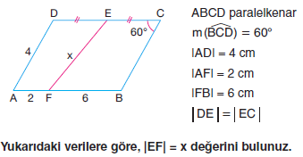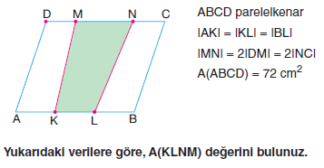

|  |  |
| --- | --- |
|  |  |
| 5) | 6) |

|  |  |
| --- | --- |
|  |  |

|  |  |
| --- | --- |
| 7) | 8) |

|  |  |
| --- | --- |
| 9) | 10) |